AEP Span Panel Finish Indicator - Box Rib

CUSTOMERS NOTE: This form must be completed, signed and returned to your AEP Span Customer Service Representative.
YOUR ORDER WILL NOT BE PRODUCED WITHOUT THIS FORM COMPLETED

Customer Name
Todays Date
Project Name
SO #

Box Rib

This profile is for
WALLS ONLY
I expect the paint to be on this side

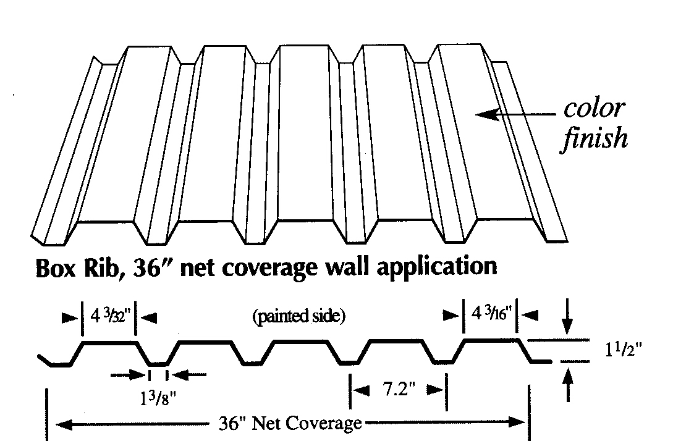
Reverse Box Rib
I am using this panel as a
(Indicate)

Wall Roof

I expect the paint to be on this side

